**Proposal for a Motion to Westmeath PPN Plenary**

15th Nov 2023

Alison Hough BL, WECAN (Westmeath Environmental and Climate Action Network)/TUS

1. **Proposal**:

“That this Plenary send a letter to the Joint Oireachtas Committee on Environment and Climate Action supporting the recommendations of the Citizens Assembly on Biodiversity and calling for the Committee to recommend their adoption in full.”

1. **Background**:

Dr. Peter Doran of Queens University Belfast is working on the Rights of Nature project in on an all-island basis. He and I also put a submission[1] to the Citizens Assembly on Biodiversity that called for Constitutional rights for citizens and for nature, and Constitutional rights for citizens in relation to public participation in environmental matters which were adopted in the final recommendations of the Citizens Assembly on Biodiversity.[2] He has recently given evidence to the Joint Committee on Environment and Climate Action in its ongoing examination of the recommendations on the Report of the Citizens' Assembly on Biodiversity Loss. Dr. Peter Doran has requested that Westmeath PPN send a letter of support for the recommendations of the Citizens Assembly on Biodiversity.[3]

1. **The text of the proposed letter from the Plenary to the Joint Oireachtas Committee on Environment will simply state (happy to accept amendments from the floor)**:

"Westmeath PPN Plenary commends the ongoing work of the Joint Oireachtas Committee on Environment and Climate Action on its consideration of the Report of the Citizens Assembly on Biodiversity. The twin climate and biodiversity crises represent an existential threat to humanity, making the Committee's work important, timely and urgent.

Westmeath PPN Plenary notes with approval the recommendations by the Citizens Assembly across a range of key areas representing the vital building blocks of a healthy environment and society.

The Plenary notes in particular those recommendations 31 / 31(a) - (d) in relation to the right to a clean and healthy environment, rights of nature and the rights of citizens to public participation in environmental decision making, to access environmental information, and for access to justice in environmental matters, and that these be placed on a Constitutional footing.

Westmeath PPN Plenary supports the recommendations of the Citizen’s Assembly on Biodiversity Loss as the outcome of the democratic process, and calls on the Joint Oireachtas Committee on Environment and Climate Action to recommend the adoption in full of the recommendations of the Citizens Assembly on Biodiversity Loss.”

1. **Recommendations of the Citizens Assembly on Biodiversity Referenced in the letter:**

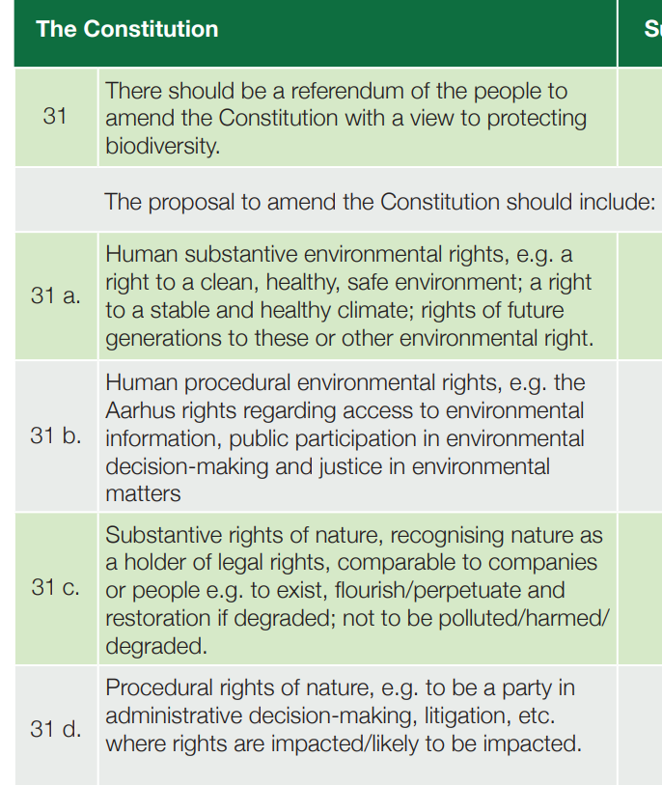

1. EJNI Submission to the Citizen’s Assembly on Biodiversity <https://ejni.net/wp-content/uploads/2022/09/EJNI-Submission-to-CA-Sept-2022.pdf>
2. See report of the Citizens Assembly on Biodiversity Loss here <https://citizensassembly.ie/wp-content/uploads/ReportonBiodiversityLoss.pdf>
3. See details here: <https://www.oireachtas.ie/en/press-centre/press-releases/20231016-joint-committee-on-environment-and-climate-action-to-resume-discussions-on-report-of-citizens-assembly-on-biodiversity-loss/>